CSA0310 – DATA STRUCTURES
CO1 AT3

1) REVERSED:
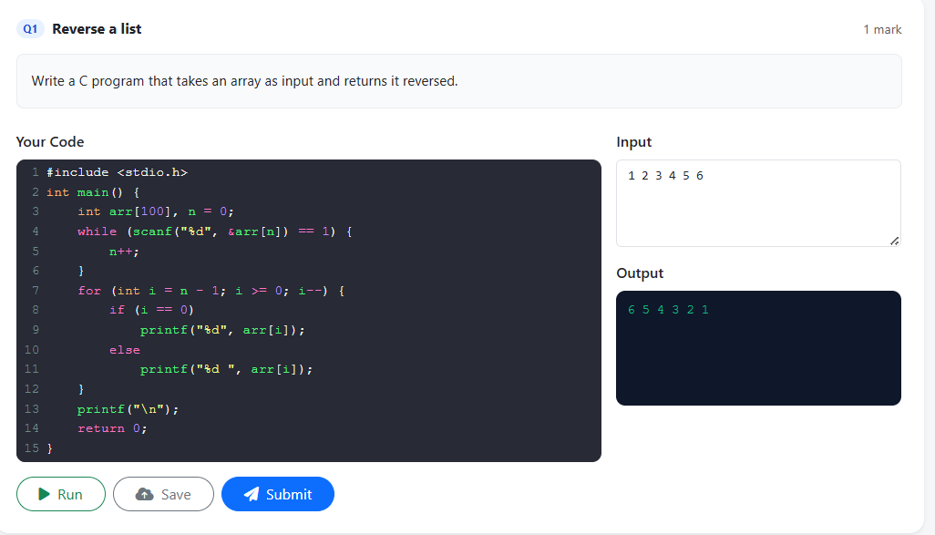

2) PALINDROME:

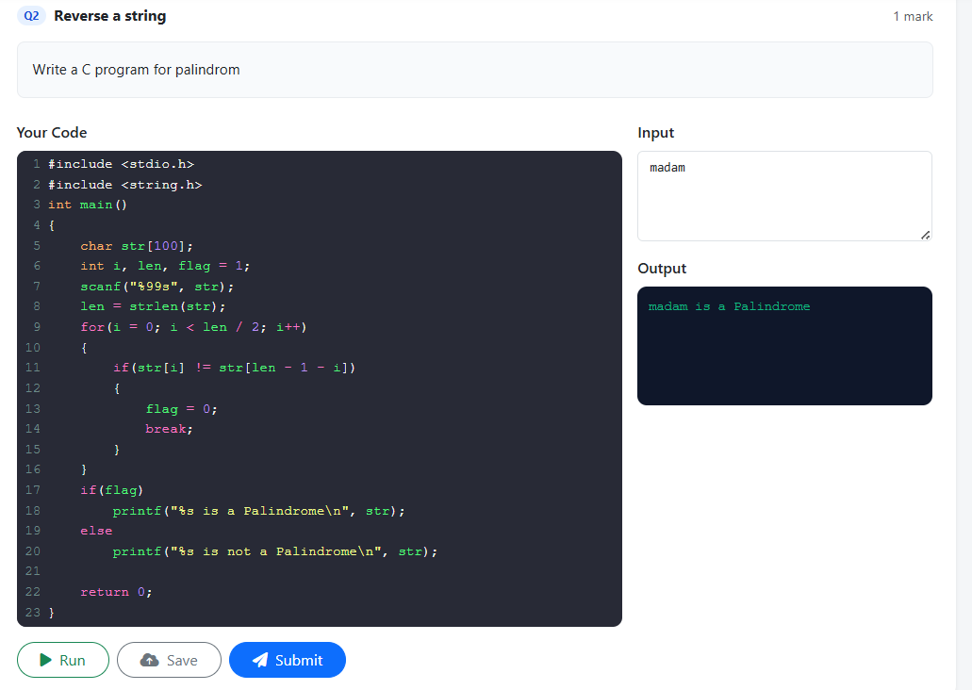

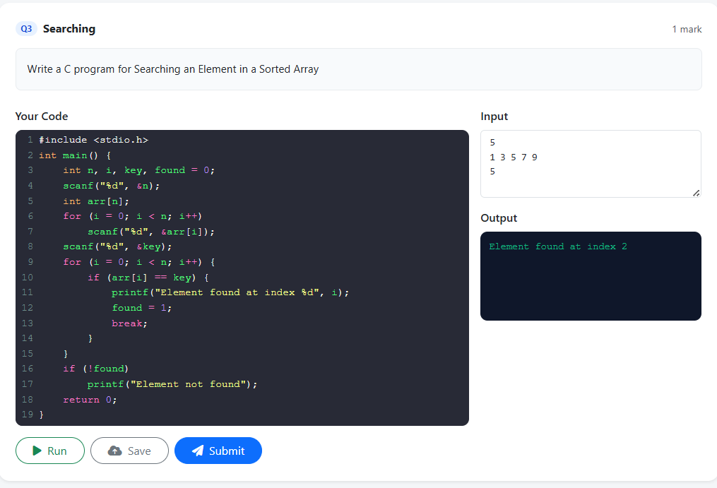
3) SORTED ARRAY:

